Chapter 3, Problem 69.

For the circuit in Fig. 3.113, write the node voltage equations by inspection.

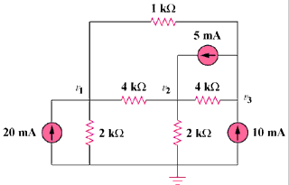

Figure 3.113
For Prob. 3.69.

